

Access to Court Applications by non-Court Agencies

:

Prepared By:

Sacramento Superior Court, MIS Dept
June 1, 2002

TABLE OF CONTENTS

Introduction 3
1. Request for Service 4
2. Renewal of Service 4
3. Change of Service 4
4. Termination of Service 4
5. Billing Information 5
6. Security 5
7. Workstation Requirements 6
Attachment A - Request for Service for Court Application Form 7
Attachment B - Access to Court Application(s) – Cost/Fee Information 10
Attachment C - Using The Court Applications Server 11
Attachment D – Implementation Schedule Error! Bookmark not defined.

Introduction

With the Sacramento Superior Court the proprietor of information that is valuable to agencies outside of the court, it is important to provide access to that information to improve service to the public. This document details the steps required for any agency to request access to court information. Any questions on procedures or other information contained within this document should be directed to the Sacramento Superior Court, MIS Department Help Desk at 874-7707.

History

As automation expanded within the Court it became apparent that other county, city and state agencies had a need to view or even update Court information.

In 1995, with the implementation of Court Juvenile Automation System (JAS), the County determined that an inter-agency application to support the juvenile case management was required. To temporarily meet the county needs, the Court and County agreed to share data with the Court and established a process to meet those requirements. This was intended as only a temporary fix until a permanent solution could be implemented such as a new juvenile system, i.e., the KIDS project. However, the County Juvenile (KIDS) program was never implemented and the temporary access remained in place.

In addition, the mainframe application to support the Courts Traffic system (MCCS) was deemed not Y2K compliant, therefore the Court migrated to a personal computer based system in 1999 (ICMS). To support those agencies with a need to access traffic data, the Court had to grant access directly to the server using each workstation’s network address and loading software to the workstation itself. This too was a temporary solution to provide continuity to agencies that needed access to Court data.

This project was initiated to resolve the problems with the current methodology of accessing Court applications. The benefits to both the Court and other agencies that require access include:

- Improved security of sensitive data
- Accountability of who is actually using the systems
- Internet based application, which eliminates the need to load software on individual workstations or agency servers
- Improved response time to application
- No “lockouts” due to license restrictions

JAS and ICMS have become an integral part of not just the Court operations, but important for those agencies that rely on the data provided. Agencies such as Probation and DHHS update information into the JAS system eliminating double data entry. DRR tracks billing and payments for the Court for traffic fines and other revenue recovery processes.

1. Request for Service

1.1 To request access to a court application, the requesting agency needs to complete MIS Form 00-02, June 2002, Request for Access to Court Application (Attachment A). Additional forms may be required if the requesting agency is outside of the Sacramento County wide area network (see paragraph 1.3). A request to access court applications may be made at any time to the Sacramento Superior Court, MIS Department. All requests for service must be signed by an agency approval authority (see paragraph 1.4).

1.2 Agency with access to the Sacramento County WAN. If you are an agency with access to the Sacramento County Wide Area Network, no additional access requirements are necessary.

1.3 Agency outside of the Sacramento County WAN. If you do not currently have approved access to the Sacramento County WAN, you will need to contact the Sacramento County Office of Communication and Information Technology (OCIT) at 875-5505 to obtain access through their network.

1.4 Agency Approval Authority. Each agency requesting service needs to provide the Sacramento Superior Court, MIS department, the names of a primary and alternate approval authority. All forms submitted to request access to court applications, must be signed by the agency’s approval authority in order to activate a new user account. Any requests for service submitted without the agencies approval authority signature will be returned to the requesting agency.

2. Renewal of Service

Service renewal will automatically continue unless a customer is terminated by their respective agency.

3. Change of Service

All changes for access to any Court application can be made by submitting MIS Form 00-02, Request for Access to Court Application Form.

4. Termination of Service

4.1 Termination of services for access to court application(s) must be made in writing to the Sacramento Superior Court, MIS Department, HelpDesk, Mail Code 02-101, 720 Ninth Street, Sacramento, California 95814. The Request for Service for Court Applications, MIS Form 00-02, Rev 06-00 can be used to terminate service or the termination may be in memorandum format which includes the authorized customer’s name, email address, and organization.

  - Service will be terminated if a customer has not activated their account within ten days of notification of a new account. If a new account is not activated within 10 days, the customer and the agency approving authority will be notified that the account has not been activated. If the account is not activated in the five days after initial notification, the account will be terminated.

4.3 Activated accounts that do not have activity for six months, will be identified for termination. Each agency will receive a notification of inactive accounts. Five days after notification, if no response from the agency, these accounts will be terminated.

5. Billing Information

  - The Sacramento Superior Court will charge an annual license fee for each application accessed. The connectivity period will coincide with the standard fiscal year, starting July 1 through June 30. The license and setup fees will be reassessed every fiscal year and each participating agency will be notified of any increase or decrease of fees. See Attachment B for initial billing information.

5.2 The Court is required to charge for any costs relating to connectivity. The cost of maintaining the applications is the full responsibility of the Court. Connectivity costs will be distributed between agencies based on the percentage of use. This will include any hardware and software replacement and enhancement costs relating to connectivity to the system.

  - An activity report will be prepared and submitted to OCIT and participating agencies not later than December 1st of each calendar year. This report will include the following information:

- Total number of users per agency
- List of users by agency
- Server configuration
- Projected server costs for next fiscal year

This information will be used to determine agency costs for the next fiscal budget cycle.

  - OCIT will coordinate cost information and perform billing tasks associated with this service.

6. Security

6.1 Security Agreement. Because of the sensitivity of court information, each authorized customer to a court application must have a signed Sacramento County security agreement on file with their employing agency. It is the responsibility of the requesting agency to ensure their staff is in compliance with this security policy.

  - Password Expiration Period. Each authorized customer will be assigned a network user identification and password to access the court network. The passwords will expire every ninety days. Failure to renew the passwords will flag the user ID and notification will be sent to the requesting agency that the account is no longer active.

6.3 Termination of Service. The Sacramento Superior Court reserves the right to deny service to any customer. Any user that is not confirmed annually by their respective agency, will have their access terminated.

6.4 Generic Logons. Generic logons are not allowed. Logons will be restricted to a single session at a time and attempts to access the Citrix server with a logon that is currently in use will be denied.

6.5 Application & Network Logons. Two separate logons will be required to access the Court’s applications. One for network access, the second will be the application logon and password. These passwords will not be “synced” and must be entered each time a customer accesses the program.

7. Workstation Requirements

For details on workstation requirements, please refer to Attachment C, Using the Court Application Server. Step-by-Step instructions are included.

Attachment A

Attachment A - Request for Service for Court Application Form
Superior Court of California
County of Sacramento


Request for Service for Court Applications
Please complete the following information.
Agency: |  |  | Justice Agency |  |  |  |  |  |  |  |  |  |  |  |  |  |  |  |  |  |  |  |  |  |  |  | FOR COURT MIS USE ONLY (Check or initial box, and add date)
Address: |  |  | Street: 123 Some Street |  |  |  |  |  |  |  |  |  |  |  |  |  |  |  |  |  |  | Mail Code: |  |  |  |  | Application Security Completed: Complete Date:
 |  |  | City: Sacramento |  |  |  |  |  |  |  |  |  |  | State: CA |  |  |  |  |  |  | Zip: 95814 |  |  |  |  |  | Network Security Completed Complete Date:
 |  |  |  |  |  |  |  |  |  |  |  |  |  |  |  |  |  |  |  |  |  |  |  |  |  |  | Customer Notified:
Agency Contact: |  |  |  |  |  |  |  |  | (Full name): John Supervisor |  |  |  |  |  |  |  |  |  |  |  |  |  |  |  |  |  | Comments:
Contact Email: |  |  |  |  |  |  |  |  | SupervisorJ@Saccounty.net
Contact Phone No. |  |  |  |  |  |  |  |  | 5-5555 |  |  |  |  | Fax No.
Customer Information.
 | Request Type |  |  |  |  |  |  |  |  |  |  |  |  |  |  |  |  |  |  |  |  |  |  |  |  |  |  |  |  |  |  |  |  |  | Check apps
 | New | Change* |  | Terminate |  | Customer Name  (First & Last) |  |  |  |  |  |  |  |  |  |  |  |  |  |  |  | Email Address |  |  |  |  |  |  | Phone No |  | Office Location (if different from Agency Contact) |  |  |  | JAS  Delinquincy |  | JAS  Dependency | ICMS |  | Traffic  Purge
 |  | X |  |  |  | Mary Smith |  |  |  |  |  |  |  |  |  |  |  |  |  |  |  | SmithM@Saccounty.net |  |  |  |  |  |  | 5-5551 |  |  |  |  |  | X
*Describe Change requests: |  |  |  |  |  |  |  |  |  | Change Mary Smith’s name to Mary Jones

Printer Information
Printer Type |  |  |  |  | Customer Name |  |  |  |  |  |  |  | IP Address |  |  |  |  |  |  |  |  |  |  | Printer Location |  |  |  | Network OS |  | Standalone |  |  | Network Printer |  |  | Print Driver Type
HP 4 |  |  |  |  | Same |  |  |  |  |  |  |  |  |  |  |  |  |  |  |  |  |  |  | Same |  |  |  |  |  | X |  |  |  |  |  | Win NT
Submit completed form to Sacramento Superior Court, MIS, Help Desk, Mail Code 02-101, 720 Ninth Street, Sacramento, CA 95814
Requesting Agency Approval |  |  |  |  |  |  |  |  |  |  |  |  |  |  |  |  |  |  |  |  |  |  |  |  |  |  |  | Comments: (See reverse for additional space)
(Signature): |  |  |  |  |  |  |  |  |  |  |  |  |  |  |  |  |  |  |  |  |  |  |  |  | Date:
(Print Name & Title) |  |  |  |  |  |  | John Supervisor, IT Director
Phone No. |  |  |  |  |  |  |  |  |  |  |  |  |  |  | Fax No.

Instructions - Request for Access to Court Application

Please complete all information requested on the form, unless it is indicated optional. If you have any questions, please contact the MIS Help Desk at 874-7707.

Agency: Clearly print the name of the agency requesting access to the court application.
Address: Input the street, city, zip address for the agency requesting access to the court application.

Agency Contact: The full name of the person to contact at the requesting agency
Contact email: The contact person’s email address
Contact Phone and Fax Number: Self-explanatory

Customer Information: This information is required to obtain a new customer account to access a court application or to make changes to an existing account. More than one account can be requested per form.

Request Type: Select the type of request. New service is for first time request or a reinstatement of service. Change service is to make a modification to your current service, this includes name change, password, etc. Termination is to stop all services for this specific account.
Customer Name: Enter the customers first and last name. Print clearly, these will be used to create user ID’s.
Email Address: Enter the customers email address.
Phone No.: Self-explanatory
Office Location: If the office location of the customer is different from the agency contact address, please complete this field. If it is the same, you may it leave blank.
JAS Dependency, JAS Delinquency, ICMS, Traffic Purge: Check the court application that access is requested for. More than one application can be selected.

Printer Information: Please complete all sections if you wish to printer capability for your selected application.
Printer Type/Model. Describe the printer, for example HP LaserJet 4 plus
Customer Name: Enter the name of customer assigned to this printer
IP Address: If the printer is connected to a network, please include the IP address.
Printer Location: Include the office location if different from the customers office location. This may also be a room number.
Network OS: Enter the Network Operating System, i.e., NT or Novell
Standalone/Networked. Please select one.

Change Description. Describe changes for those customers checked Change under Request Type. For example, if you are requesting that Mary Doe’s user name be changed because she married, you would make a note: Mary Doe, name change to Mary Smith. If you are changing the license assignment, please note here the name of the current licensee and the name of the new user. Be sure to fill out new user name in the Customer information line, and check the Change box.

Requesting Agency Approval: The name and signature of the requesting agency’s approval authority for requesting services through the court. Forms submitted without the appropriate approval authority name, may be returned to the agency for correction.

Submit forms to: Sacramento Superior Court, MIS, HelpDesk, Mail Code 02-101, 720 Ninth Street, Sacramento, CA 95814

COMMENTS

Attachment B

Attachment B - Access to Court Application(s) – Cost/Fee Information

Attachment C - Using The Court Applications Server
Using The Court Applications Server

1. Introduction

This document describes how to use the Court applications server from computers that are not members of the Court domain. This would include County Agencies that need access to Court applications such as the Juvenile Automation System (JAS) and the Traffic Case Management System (ICMS).

2. Prerequisites

Before using the instructions contained in this document for logging in and using Court applications from outside the Court domain, the following prerequisites must be met.

- You have submitted Court MIS form 00-02 and been granted access to a Court application.
- You have a computer that meets the following requirements.

Microsoft Internet Explorer 4.0 or higher

80486 or higher Microprocessor

8MB of RAM or higher

Windows 95, Windows 98, Windows NT 4.0 and Windows 2000 operating system

VGA or SVGA video adapter with color monitor

At least 2.5 MB of free disk space

Mouse for navigation

Connection to the Sacramento County WAN

- You have received a login name and password for the application(s) you will be accessing.
- You have received a login name and password for access to the Court Application Server.

3. Password and User Name Rules

The following are the rules for passwords and user names on the Court Application Server.

- Passwords can consist of both letters and numbers.
- Passwords must be a minimum of 6 characters.
- Passwords must be changed every 90 days. You will be prompted when it is time to change the password.
- Passwords cannot be reused when they are changed.
- After 6 incorrect login attempts, your account will be disabled. After 30 minutes, the account will be re-enabled.

4. Connection Rules.

The following connection rules have been implemented. These rules will cause you to be disconnected from the Court Application Server.

- Disconnect time out = 10 minutes. If you should loose your connection, you can reconnect and will be where you left off. After 10 minutes, your connection will be reset.
- Idle time out = 1 hour. If you connect to the Court Application Server and do not do anything for 1 hour, you will be disconnected.

Procedures for Connecting, logging on and changing password

- Open your Internet browser and enter the following information in the address field. “http:\\courtapps.saccourt.net”. This will take you to the Court Remote Applications web site as shown in figure 1 below.

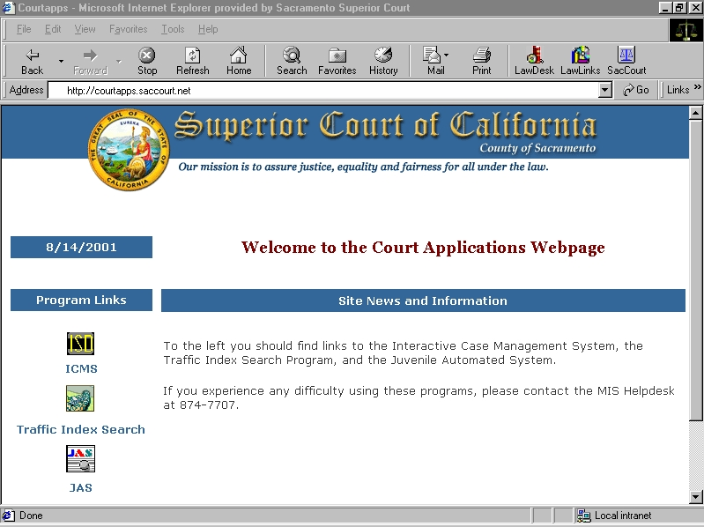
Figure 1

- Once you are at the Court Applications web site, click on the icon for the application that you would like to run. A new page will open and you will see the Security Warning screen shown below.

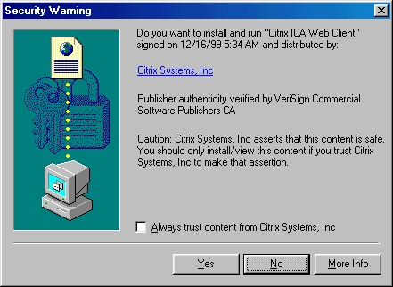
Figure 2

- On this screen, check the box “Always trust content from Citrix Systems, Inc” and then click on the Yes button. If you do not check the box, you will get this screen every time you connect. You will now get the screen shown in figure 4.

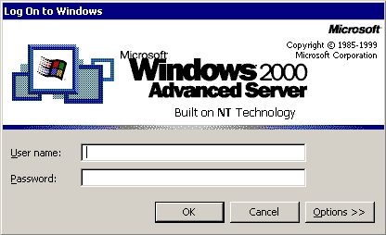
Figure 4

- Once you have received the login screen shown in Figure 4, Enter the login and password for the court application server that you were provided. If this is the first time that you have logged in, you will see the screen shown in figure 5. If you have logged in before, go to step 8.

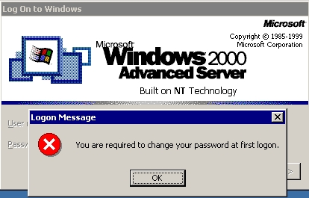

Figure 5

- Click OK and you will see the screen shown in Figure 6.

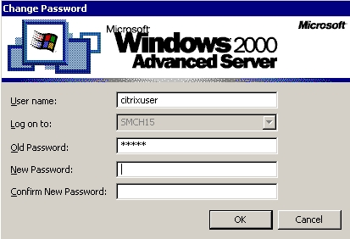
Figure 6

- Enter a new password in the New Password box and then enter the same password again in the Confirm New Password box. Click on OK. You will see the box shown in Figure 7.

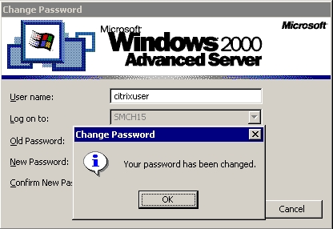
Figure 7

- Click on OK .

- You will now see the first screen of the application that you wish to run. To continue, follow the instructions provided for that application.

- If you experience any problems or need assistance, please call the Court MIS Help Desk at 874-7707

